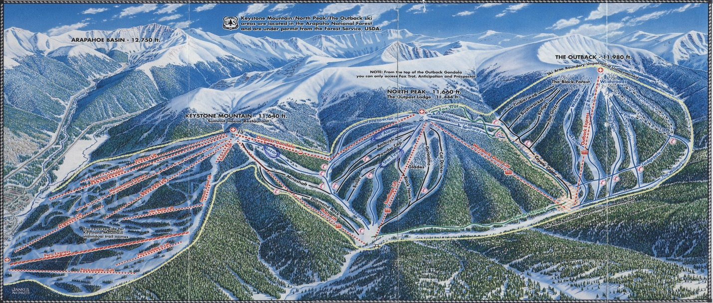

Sometimes Keystone Resort seems to fall in the shadow of its nearby sister resort of Breckenridge. But it would be a huge mistake to underestimate this resort for many reasons. It has a total vertical of nearly the same at well over 3000’ and a stated total acreage larger than Breck. What it lacks in high alpine terrain, it gains in a very efficient mountain layout with long runs and consistent fall lines. If you want steeps and bowls, go to Breck. But if you’re looking for some of the best long sustained groomers, endless bump runs, or solid tree runs, Keystone is your place of choice. On top of this, it’s one of the closest destination resorts to Denver and the most affordable of the four Vail owned resorts in the area.

- Parking
- Lift Access & Planning
- Groomers
- Bumps
- Trees
- Powder Days
- Hike-To terrain

PARKING
FREE PARKING: The River Run Gondola lot, formerly known as the Montezuma lot will remain FREE every day (a bit of a walk, but overall pretty good deal – no shuttle buses). Families with young children or cars with four or more passengers will be directed by parking staff to first-come, first-served spaces up front.
TIP: The second lot entrance is preferable.
If there is a traffic backup on the Hwy 6 entrance, continue up to the next exit on Montezuma Rd and back track to the lot entry.
The best spots (shortest walk) are closest to the lane of this second entrance.
$10 PARKING: The Mountain House East E lot (formerly known as the Pika lot).
$20 PARKING: The other Mountain House base area lots, Mountain House West A, Mountain House West B and Mountain House East D (formerly the Marmot and Porcupine lots).
$30 PARKING: Paid parking lots servicing River Run - Hunki Dori (gone for 2019-20 season) and Gold Bug.
Pay lots will be changing from an entry gate system to one involving the Passport Parking app and kiosk system. Guests can park at a space and pay in advance at the kiosk, or install the Passport Parking app and pay remotely on their phone.

LIFT ACCESS & PLANNING

