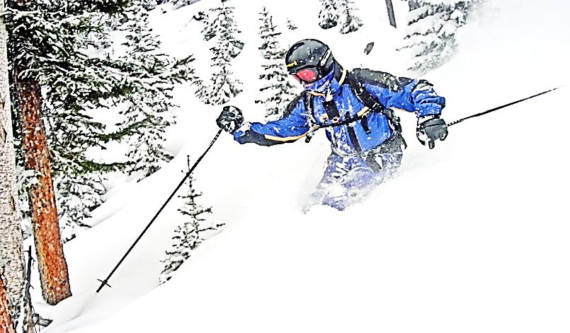
www.DesertSnowJunkies.com

EXPERT’S GUIDE
to
PURGATORY
at
DURANGO MOUNTAIN RESORT

Home of
San Juan UNTRACKED
Snowcat Skiing

Tucked into the spectacular San Juan Mountains between Durango and Silverton, Purgatory, like its neighbor Telluride, boasts some of the finest scenery in the lower 48. At just over 2000’ vertical, 1300+ acres, and 10 lifts, “Purg” just squeaks into the large ski resort category. The southerly locale favors sunny days and mild weather, but the 9000' base elev. provides an impressive 260 average annual inches of snow.
- - - - - - - - - - - - - - - - - - - - FOLD HERE - - - - - - - - - - - - - - - - - -
Far removed from the busy I-70 corridor, it is known for a hometown, laid back, friendly atmosphere at affordable prices. Lift lines are a rare occurrence, thus allowing for endless laps on the uniquely “benched” roller coaster terrain. Although lacking in such attributes as bowls and chutes, there is easily enough here to keep a good skier happily occupied for many days straight.

The mountain is essentially an 11,000' ridge that runs east to west with mostly north facing slopes roughly divided into three segments. First is the “front side” terrain served by the “six pack” Express Lift #1. This area has a nice mix of varying terrain. The second mid-mountain area is served by Hermosa Lift #3 and is dominated by some nice rolling groomers. The third “backside” area is served by Legends Lift #8 and has some of the resort’s better expert terrain and tree skiing. A system of extensive cat trails is used to get back and forth between these areas.

This guide is meant to be used in conjunction with the trail map and also the daily grooming report, which are both usually available at the ticket windows, in the lift line map dispenser, and various other locations.
Obey all rules printed on the trail map!

>From the base area, aside from some beginner lifts, most skiers start up on the six person Express Lift #1. While a typical daily choice for a groomer warm-up might be Upper Hades or Paradise which are usually alternately groomed every other night, some special grooming reports are worth noting. Pandemonium is usually groomed once or twice a week and makes an already classic run a real screamer on fresh corduroy.
TIP: On the backside Ray’s Ridge is also groomed once or twice a week and makes it well worth heading straight over to it for a couple laps before it gets skied off. If they also happen to break out the winch-cat for the bottom section, it’s guaranteed to put a smile on your face. (A true gem is the very rare grooming of Styx on the front side and it is lucky to occur only once a season if that).

Purg has no shortage of nice groomers with Boogie and Peace off Lift #3 and Sally’s and Chet’s off Lift #8 all offering some of the area’s signature rolling terrain.

>After a couple warm-up runs (or not), most serious skiers start heading west. To get all the way to the backside, one must transit Lifts #3 or #5. In addition to the two intermediate groomers mentioned above, Lift #3 does have a few worthwhile offerings for the expert skier. Dead Spike on skier’s far left is popular due to the fact that they groom only the left side leaving the right to form small moguls on a moderate slope that are great for learning technique or tender knees.
TIP: When base depths are ample and the snow is soft, Harris Hill and Snag offer a nice variation with the bottom sections including Crazy Joe’s and Grizzly Gully being some fun bump alleys.

From the top of Lift #3 continue west on Legends. Much like the traverse from Lift #1, a tedious cat trail is ultimately rewarded with a fun lower section.
TIP: A good choice here is continuing all the way to the bottom of Lift #8 on Siegele Street which, if it’s been groomed, is a must do.

Future plans have Lift #8 being replaced with a high speed quad, but for now the fixed three-seater offers minimal lift lines for expert skiers trying to maximize their vertical on the backside runs. This is where most expert skiers tend to spend the middle of their day, and aside from the trio of groomers on the skier‘s far right, the terrain is predominately expert. Ray’s Ridge, as mentioned earlier, offers the most consistent fall line and is a very popular “blue / black“. The steep lower portion below the cutoff to midway loading can be especially fun.

Following a storm, the best bet to find the last remaining stashes of powder would be the Paul’s Park glade area, especially in the alleys just skier’s right of the lift. Boudreaux’s can be one of the last trails to get completely tracked out along with Vincent’s - but beware if the snow is a bit heavy there can be some troublesome flat spots.

Blackburn's Bash from the top offers a challenging steep pitch under the lift and tends to have excellent snow due to its shaded aspect. Just make sure and come with your “A-game” since you're sure to be critiqued by every skier on the lift! Continuing
down under the lift, you'll come to a very popular moderate bump section just above the midway
loading station. From there the bottom pitch can be
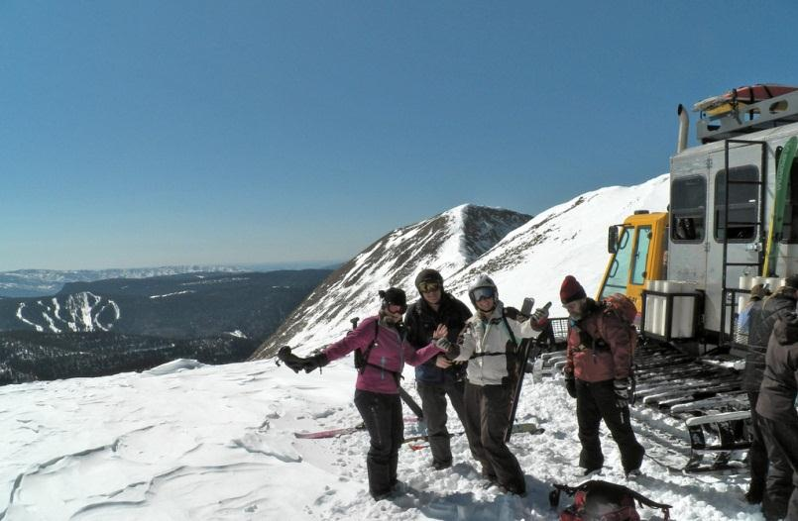
SNOWCAT TOURS

(800) 208 - 1780
WWW.SANJUANSKI.COM

hit or miss. Try it at least once noting that skiers right and left can offer quite different conditions with longer moguls blending to shorter to groomed as you trend to the left on the slope.

Purg’s only dedicated tree skiing runs are the moderately pitched Poet’s Glade, the steep and dicey McCormack’s Maze area on the far back side, and the new Ambassador's Glade on the front side.
TIP: The trick to Poet’s is to stay within the tree island between Sally's and Vincent's. To avoid getting spit out skier’s left onto Sally’s, a persistent track back to the right will be rewarded with a continuous series of narrow alleys all the way down to the Legends trail.

McCormack's is indeed a Maze and it would be difficult to ever ski it twice the same way. Tightly spaced trees, steep pitches, and varying fall lines contribute to an adventurous experience. Here too, persistence pays by seeking out nice semi-connected alleys and spicey tree shots. Beware - this is new terrain with freshly cut timber and stumps requiring some extra snow coverage. NEVER SKI THIS AREA ALONE and always keep your partner in sight.

TIP: Instead of bailing out right at the exit trail onto Lower Ray's, stay next to the boundary rope all the way to the bottom for one last good tree shot.
>While it is possible to return from the top of Lift
#8 to the front side base area in one run, working your way back provides an excellent opportunity to sample some of the more difficult terrain Purg has to offer. If you do need to get back pronto, take the BD&M Expressway (aka S&M), a tediously flat cat-trail all the way to at least Zinfandel, and preferably past that to Airmail or The Bank.

Otherwise, from the top of Lift #8 head back on Joan's Jubilee to Dante's Restaurant which, by the way, is a great place to break for a quality lunch with fabulous views. From Dante's take upper Bull Run for some tight warm-up bumps down to the challenging steeps of Lower Bull or over right to some serious bumps on Wapiti.

From the top of Grizzly Lift #5 you can finally head straight back to the front side by accessing the BD&M Expwy as mentioned above, or unload at Dantes and transit back through Lift#3 via Dead Spike or Path to Peace.
TIP: A slightly tricky, but good route down from the Expwy, or Silvertip from the top of Lift #3, is on Airmail down to a somewhat hidden hard right turn on Walk-a-Lot. A few pole strokes will get you over to El Diablo and down Demon to the base, or avoid the crowds by short-cutting up Engineer Lift #2 back to the top of the front side.

Keep in mind Demon is a slow skiing zone and is routinely monitored. Ski cautiously down to the base area or risk losing your ticket.

>From here you can finish the day on some classic front side runs. While your legs still have some mileage left, Styx would be a good first choice. This is a great run with good vertical in a neat variety of shapes. Skier's left and right sides of this run offer an entirely different character and given the right conditions, this can often be a candidate for “best run of the day”.
TIP: If there happens to be a race in progress blocking the normal access past the Nastar start shack, another entry is open above, just past the Ski Patrol shack.

The Ambassador’s Glade, while a bit short, can be accessed on the front side from Mercy and offers some of the area’s only small, but sweet cliff shots.

Upper to Lower Hades is a cool mix of rolling groomer to a serious drop into rolling bump pitches. Combine steep bumps with typically challenging snow conditions and you'll find this section a good place to test your crud skills. The bottom section of Lower can often have some of the nicest bumps at Purg.

And finally, to ramp it down just a bit for the last run, Paradise to Pandemonium, which is Purg's signature front side run, is another nice groomer to a veritable steep roller coaster with a choice of smooth in the middle, bumps on the right, or typically deep loose pack on the left.

The base area between the lift and the lodge is known as “The Beach”, and on a nice sunny afternoon can provide a lively and enjoyable après' ski scene, often with live music on weekends. It's definitely a good place to enjoy a cold one and reflect on the day's highlights.

WHY CAT SKI WITH SAN JUAN UNTRACKED?
* More acres than all other snowcat skiing operations in Colorado combined.
* More terrain means you are guaranteed untracked powder lines. We promise it, or your money back!
* We are conveniently located at the base of DMR.

Call or get online now to book a powder skiing trip at
(800) 208-1780 www.SANJUANSKI.COM

John FRITZSKI fritz
www.DesertSnowjunkies.com Rev 3, 2014
Nowhere in this guide does it recommend to ski anywhere off the marked trails. Always use caution and stay in control. Observe all posted signs and warnings. Trees, unmarked obstacles, and other hazards exist. Under Colorado law, a skier assumes the risk of any injury resulting from any of the inherent dangers and risks of skiing. Ski smart, ski safely!
ADDITIONAL NOTES:

If Lift #3 is crowded and you’re entering from the east (Boogie/Peace), ski around the outside of the crowd and enter from the other (west) side.

Demon is notorious for being a human pinball game. Slow down! – yellow coated safety guys are omnipresent and ready to clip your ticket. A good way to go is skiers left up on the shelf, then thru a nice open cut in the trees to the top of lower Demon. From here continue to stay far left to the bottom.

Although Purg has no “hike to” terrain, it does occasionally have some top quality “hike from”. No joke! Mon thru Thur Lift #5 does not run. If one of these days happens to be a powder day, Lower Wapiti and Lower Bull remain almost untouched. You’ll just need to make an easy flat hike over to Lift #3 at the bottom.

