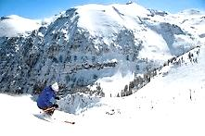
www.DesertSnowJunkies.com

Expert’s Guide
To
TELLURIDE

Telluride is renowned not only for its stunning scenery, but also for the truly hard corps skiing that comes with its massive vertical drop and abundance of inbounds “extreme” terrain. While some of the best free skiers in the world call this mountain “home”, this guide is aimed at your everyday resort expert or “weekend hotshot” wanting to get the most out of their Telluride experience.

- - - - - - - - - - - - - - - - - - - - FOLD HERE - - - - - - - - - - - - - - - - - -

Nearly half of all the runs at Telluride are expert level and while some of the recommended runs may be labeled “double diamond EX“, they can all be negotiated smartly and safely. That being said, there are hike-to chutes with tight rocky couloirs that are truly extreme so always exercise appropriate caution, stay on marked trails, know what you’re getting into, and ski within your limits.

Telluride offers an abundance of steep groomers, endless bump runs, wide open bowls, trees and chutes on over 2000 skiable acres. It has 3800’ of lift-served vertical (#4 in the US) and 4400’ if you’re willing to hike (#1). With the highest lift-served point at a lofty 12,570 feet, the resort averages over 300 inches of snow annually and needs a rough minimum 50" base for good skiing. With anything less than 70” you may find exposed junk on any ungroomed run, with the steep chutes and wind exposed ridges being particularly dicey because of thin cover.

Because Telluride has a nice quality of separating the lifts and varying terrain, lift lines are a rare occurrence and each lift tends to be dedicated to a particular type of terrain. There are a total of 18 lifts, half of which are high speed.

This guide is meant to be used in conjunction with the area trail map and also the daily grooming report, which is usually available at the ticket windows, in the lift line map dispenser, and various other locations.
Obey all rules printed on the trail map!

> Start the day by getting from the Town or Village up to the Plunge Lift 9 for some great early morning corduroy.

Either Bushwacker or Upper Plunge are usually groomed every other night. These two and See Forever to Lookout provide some of the best long, high angle groomers you’ll find anywhere. The town side runs off the Coonskin Lift 7 can tend to be a bit boney, but on any given day Milk Run and Coonskin can also be quality groomers.

Now that you’re thoroughly warmed up, you may want to hit a few of the top quality bumps and chutes to be found on the same Lift 9. It’s almost a blessing this old quad is a fixed grip. Although it zips right along, the 2125’ ascent gives your legs a bit of a rest between hard charging laps.

Probably the most popular bump run at Telluride is Mammoth. It and Joint Point merge and either offers a long hit of quality moderate bumps.

TIP: Try the far left side of Mammoth to the intersection with Joint Point. There is a trail left into the trees that will get you back on Plunge. This way you can ski some bumps, grab a quick break the groomed, and then hit more bumps all the way to the bottom of the lift on Lower Plunge.

For some usually softer and more elongated moguls, check out Spiral Stairs which is shaded and doesn’t get as much traffic. Also try Log Pile from Locals Glade or the Last Chance road off Plunge. The top is pretty gnarly if you get in off See Forever, but it skis nicely from the lower entrances. When you hit the road at the end of Log Pile you are at the top of the West Drain (may be unsigned). Don’t let this one bump wide ditch at the top scare you, this is a classic run that should be tried. It opens up to a bump-and-a-half or more, farther down. It will work you, but it’s always shaded and has good snow.

TIP: Another hidden gem is the North Chute. Get in about 100 yards down Look Out via a wild traverse (shown on map). This is a short shot, but always has good snow because it never sees the sun. When you hit the Telluride Trail road, instead of continuing down the lower North Chute, go right 25 yards down the road and try Christmas Tree Chute (not shown). It’s another bump-and-a-half wide classic.

Next head over to Apex Lift 6. The area from Alais Alley to Silver Glade is particularly
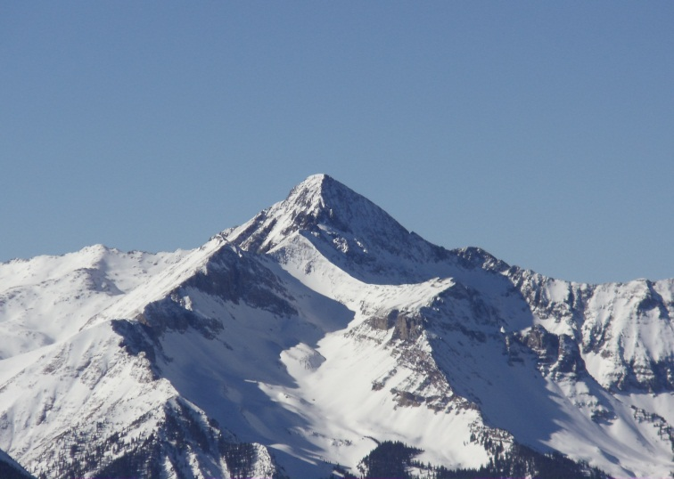

PROMO AD HERE

sweet terrain. It’s mostly shaded and tends to have good snow. For some nice open tree skiing, check out the Apex / Sully’s Glade area, but beware that due to its western exposure it can have thin cover and be icy, except late on a sunny day. Allais Alley is like a long, steep super-pipe with moguls and Chongos may provide some late powder stashes.

TIP: Be sure and check out Happy Thought, which is not an obvious choice from the top.

While the Polar Queen Lift 5 offers a few fun low angle bump runs such as Henry’s, they are short, so instead take Woozley’s Way over to Gold Hill Lift 14. Here you’ll find an exceptional choice of steeps and chutes, but beware this area is the most susceptible to poor coverage. Dynamo and Electra are usually in the best shape along with shaded aspects on Little Rose. Skier’s left gets lower angle sun and will usually provide the best snow on all these runs. You’ll notice the inviting terrain of Millions run under Lift 14, but beware getting to it may involve negotiating some wind scoured bare spots, so plan from the chair and be creative in your approach.
Now it’s on to Revelation Bowl. From the top of Lift 14 drop into the completely open bowl and enjoy the easier expert terrain anywhere you choose. Beware the exposed ridge on the skier’s right boundary can be wind scoured and very thin, but can otherwise provide late pow stashes through some thin scrubs and nice little kickers.

From the top of Revelation Lift 15 head skier’s left over to the adventurous Gold Hill Chute #1. This wide open chute skis really well and narrows down to the Goat Path traverse (to avoid the cliffs below) where it then deposits you to skier’s right onto lower Andy’s Gold and some of the steeper tree alleys you’ll see inbounds anywhere.

Moving from here over to the Prospect Bowl Lift 12 offers a variety of hike-to terrain, but while worthwhile from a “do it once” standpoint or for the scenery, most of it is considered a lot of effort for the limited return. The lift served runs are generally not very high quality with a lot of flat run-out.

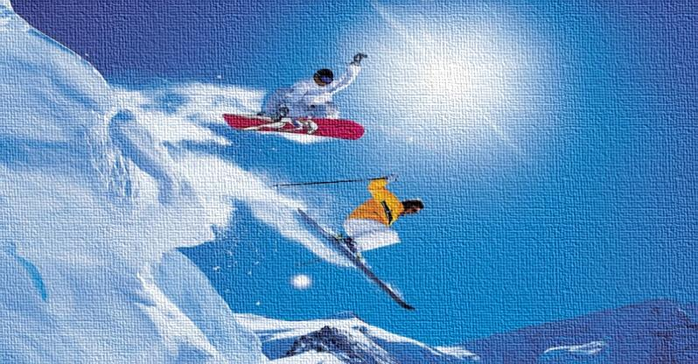
From an expert’s perspective, Lifts 4, 5, and 10 have little to offer. Although, hidden among the beginner and intermediate groomers are a couple short, but very moderate fun bump sections such as Henry‘s off Lift 5 and Hermit off Lift 4.

TIP: While this is a recommended plan of attack on a normal day, a good powder day would basically reverse the order. Many in the know head straight for Revelation Bowl and then stay the day up high skiing between Lifts 6, 14, and 15.

If you’re into the “weekend racer” scene, the Nastar course off Lift 4 is top notch with very good length and pitch.

There is lots of good food all over the mountain and the restaurants on the top of Lifts 9 and 12 usually have free sunscreen and water. Be sure not to miss the “beach” scene at Gorrono Ranch at lunch time on a sunny day. The kicked back atmosphere, good food, and nice vibes from a live musician make it hard to get back on the slopes.

Telluride also offers one of Colorado’s best professional boot fitting shops. If you need some boot tweaking try the Boot Doctors in the Mountain Village. They really know their stuff.
www.BootDoctors.com 800.592.6883
Telluride ranked 5th overall best ski resort in North America in Ski Magazine's 2013 Resort Guide, and while it may be a bit pricey, it’s a mountain good skiers just love to love. Plus they call it "the most beautiful place you’ll ever ski," and for good reason. If the terrain doesn’t blow your quads, it’s guaranteed the views will blow your mind.

I hope this guide helps you squeeze a little
more “juice” out of your Telluride experience.

Ski hard, ski safe, and enjoy!

John FRITZSKI fritz
www.DesertSnowjunkies.com

Nowhere in this guide does it recommend to ski anywhere off the marked trails. Always use caution and stay in control. Observe all posted signs and warnings. Trees, unmarked obstacles, and other hazards exist. Under Colorado law, a skier assumes the risk of any injury resulting from any of the inherent dangers and risks of skiing. Ski smart, ski safely!

